**How to make buying cats online easier**

**Major Project**

By Arain Ahmed

Student Number: 1802877

University of Bolton

Course: Computing (Top-up Year)

Supervisor: Francis Morrissey

# Abstract

Aim: The aim of this major project was to assist people to buy cats online. There were four objectives that were to simplify the process of buying a cat online.

Method: Microsoft Access was used to build a database which involved building two tables with a relationship between each other, creating forms, queries and a report. In addition, interviews were conducted to inform the design of the form. The database was tested at various key stages and the project was managed by using the Kanban Methodology.

Results: The product functions with potential and a lot of possibilities for use online with further research and testing.

Reflection: Overall, the project was successful. Areas for improvement are time management, implementation of help buttons and to continue to build knowledge and experience.

Conclusion: The project was enjoyable, and knowledge of Microsoft Access has been increased significantly.

Contents

Abstract 2

List of Tables 4

1. Introduction 5

1.1 Aim and objective 5

2. Literature Review 6

2.1 Problem Statement 6

2.2 What websites are available? 6

2.3 Access Database 8

2.3.1 Full View in Access 8

2.4 Primary Research 8

2.4.1 Individual 1 8

2.4.2 Individual 2 8

2.4.3 Individual 3 8

Secondary Research 8

3. Methodology 14

3.1 Qualitative Interviews 14

Project Plan 14

4. Development 19

Normalisation 27

5. Testing 27

Feedback 29

6. Critical Reflection 31

7. Conclusion 32

Bibliography 33

Appendices 33

Proposal Form 33

Research Ethics Checklist 36

Project Diary 42

**List of Figures**

Figure 1: Pets4Homes Homepage 5

Figure 2: Pets4Homes Search Results 5

Figure 3: RSPCA Cat Results 6

Figure 4: Cats.org Pre-purchase Checklist Question 1-2 7

Figure 5: Cats.org Pre-purchase Checklist Question 2-3 8

Figure 6: Cats.org Pre-purchase Checklist Question 3-4 8

Figure 7: Cats.org Pre-purchase Checklist Question 5-6-7 9

Figure 8: Cats.org Pre-purchase Checklist Question 8-9 9

Figure 9: Cats.org Pre-purchase Checklist Question 9-10-11 10

Figure 10: Cats.org Pre-purchase Checklist Question 12-13 10

Figure 11: Cats.org Pre-purchase Checklist Question 13-14 11

Figure 12: Gumtree Listing of Kittens 12

Figure 13: A Blank Cats Table 16

Figure 14: Selecting The Form Option 17

Figure 15: A Blank Form Created 17

Figure 16: A Form with data inside of it 18

Figure 17: The second half of the form 18

Figure 18: The last part of the form 19

Figure 19: Opening the property sheet for the Cats form 19

Figure 20: The Property Sheet having the settings changed 20

# List of Tables

Table 1: Project Plan Milestones 13

Table 2: Project Plan Gantt Chart 15

Table 3: White Box Testing For Application 25

# Introduction

The following report presents the feasibility of creating an online system to manage the purchasing of cats over the internet. This includes the aim and objectives, researched information to inform development, the methodology followed, tools and techniques used during development, and a critical reflection evaluating the project. The project was managed using planned deliverable and timescales

## 1.1 Aim and objective

The aim of this major project is to assist people to buy cats online.

The objectives are to ensure buying a cat online is a simple process by:

1. Providing more information about the purchasing process which impacts both buyer and seller
2. Providing more information to the buyer about the cat
3. To identify existing issues about buying a cat online
4. To resolve the identified issues through the implementation of solutions.

# Literature Review

## 2.1 Problem Statement

A database system is required for people who want to buy a cat because they would need to know important information before choosing the one that is right for them, such as the cats age and the way they interact with other people and other cats. The system is also required because it makes it easier for people to set their preferences to search for certain types of breed of cat.

## 2.2 What websites are available?

There are various websites that sell cats online including those people who have new-born kittens that need homes because they may not have enough space to keep them. Another reason people would sell their cat online is that they are unable to keep it anymore because it may have become too much for them, it may cost too much or the cat may not get along with other members of the family, due to allergies or becoming violent. These people use websites to advertise their pet such as Pets4Homes, Gumtree and Preloved.

The screenshot below illustrates a website Pets4Homes, which people use to sell their pets online.

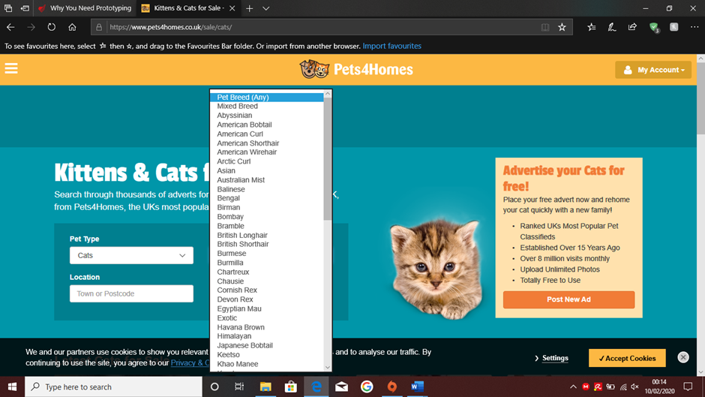

Figure 1: Pets4Homes Homepage

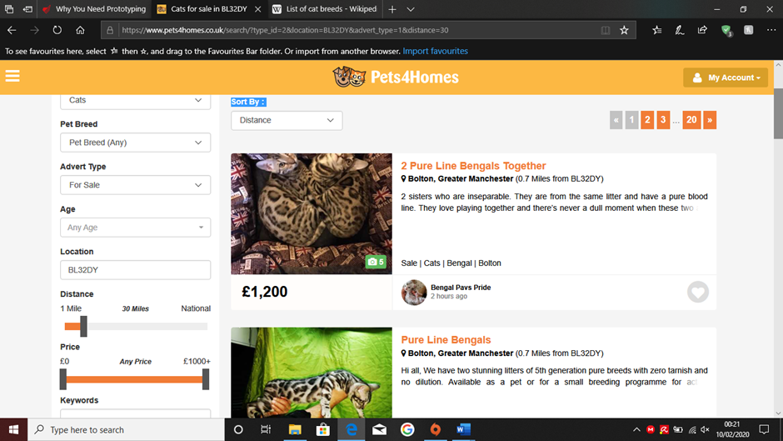

Figure 2: Pets4Homes Search Results

Cats are also sold online by animal rescue charities who have sheltered cats which have been abused or left homeless, with the intention of rehoming them to a new owner. These charities are the RSPCA and Cats.org.uk.

The screenshot below illustrates a charity website RSPCA, being used to advertise in order to rehome homeless cats. (RSPCA, 2020)

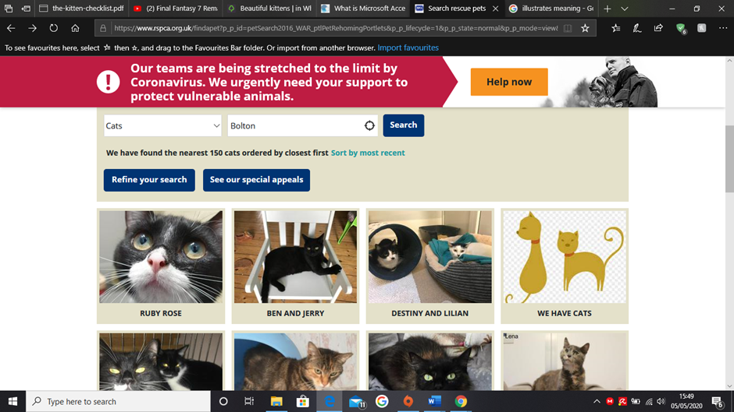

Figure 3: RSPCA Cat Results

## 2.3 Access Database

The proposed system to sell and buy cats online, will be created by using Microsoft Access. This software was chosen because it is simple to use and is perfect for making a prototype of the database. A prototype is important because it is not the final version of the application and it is easier to integrate additional items at a later stage, as the development progresses, due to its flexibility. If there is an issue with the prototype, it is possible to go back and change it before adding it into the final build. There is also support online for the software, this will make it easier to find solutions to issues that may arise and can be resolved using its user-friendly interface. It uses Visual Basics Language which is used in the Microsoft Office programs.

### 2.3.1 Full View in Access

Research was undertaken into Access software in order to find out how to create a full view form. Within Access, the form needs to be designed in design view in order to change the layout of the form and access the property sheet to alter the way the form opens. To action this, it was necessary to click on “other” and change the “Pop Up” option to yes, so the form will open in a new window. Subsequently, it was necessary to click on “Event” and select the “On Load” option which opened a command line where the command “DoCmd.Maximize” was inserted between the code that was already there.

## 2.4 Primary Research

In order to inform the development progress of the access database system to buy cats online, it was necessary to undertake interviews with 3 individuals who may or may not have had knowledge about buying a cat online.

### 2.4.1 Individual 1

This person has said “They would use an online cat service but aren’t sure about whether the kitten is healthy or not”. This demonstrates that they need more help when it comes to online shopping as they could make a mistake when it comes to picking out the right kitten for them and to also help them if they need to spend additional expenses on vaccinations.

### 2.4.2 Individual 2

This person has said “They don’t know anything about cats and they wouldn’t know what to do”. This demonstrates that they would be completely lost when it comes to buying a cat and they would make a lot of mistakes and they would need as much as help as they need if they ever do think about buying an animal online

### 2.4.3 Individual 3

This person has said “They would buy a cat online but would also use the cats.org checklist as a side note”. This demonstrates that they would need a checklist inside the program and give out the right specific information they are searching for so then they can put their fears aside and make the right choice.

## Secondary Research

The Secondary research involved using cats.org.uk in order to specify what is needed when someone is thinking of buying a kitten, the screenshots will be shown below. These screenshots ask questions which help an individual who is thinking of buying a kitten, they should have a better understanding of what to expect, and able to decide, once they are 100% sure of buying the kitten that they want.

(Group, n.d.)

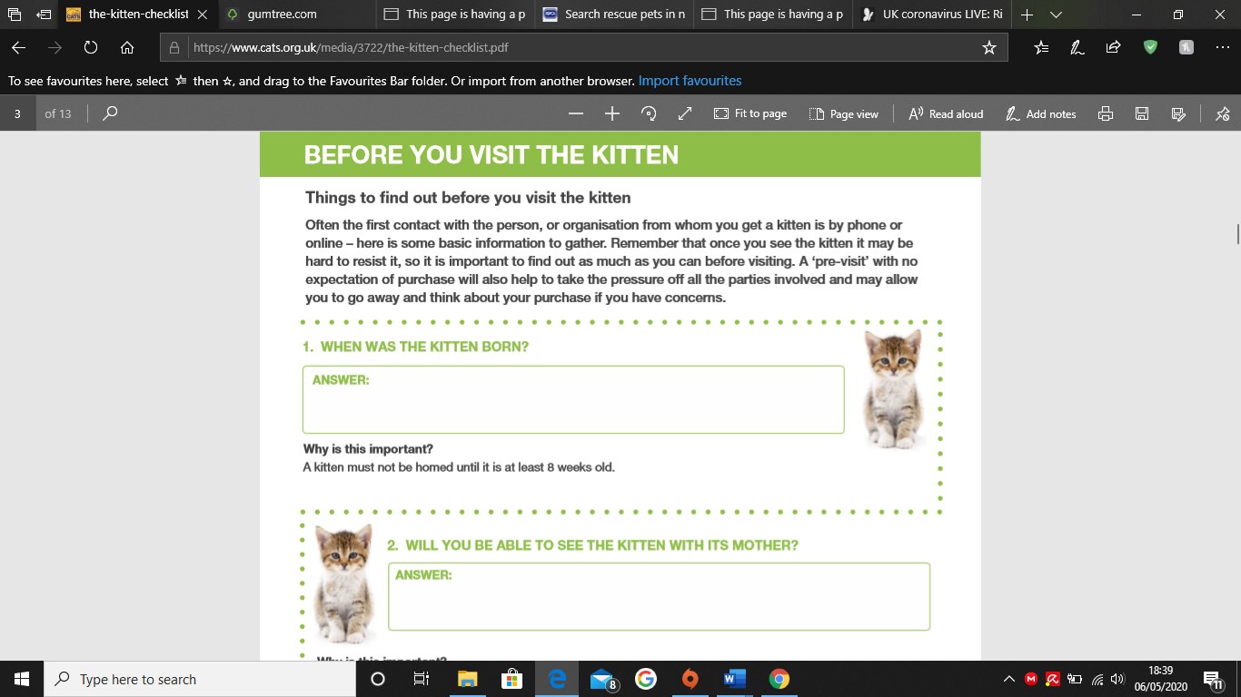

Figure 4: Cats.org Pre-purchase Checklist Question 1-2

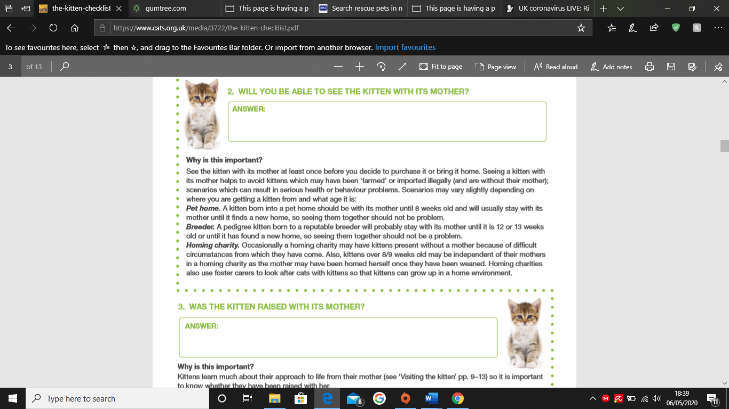

Figure 5: Cats.org Pre-purchase Checklist Question 2-3

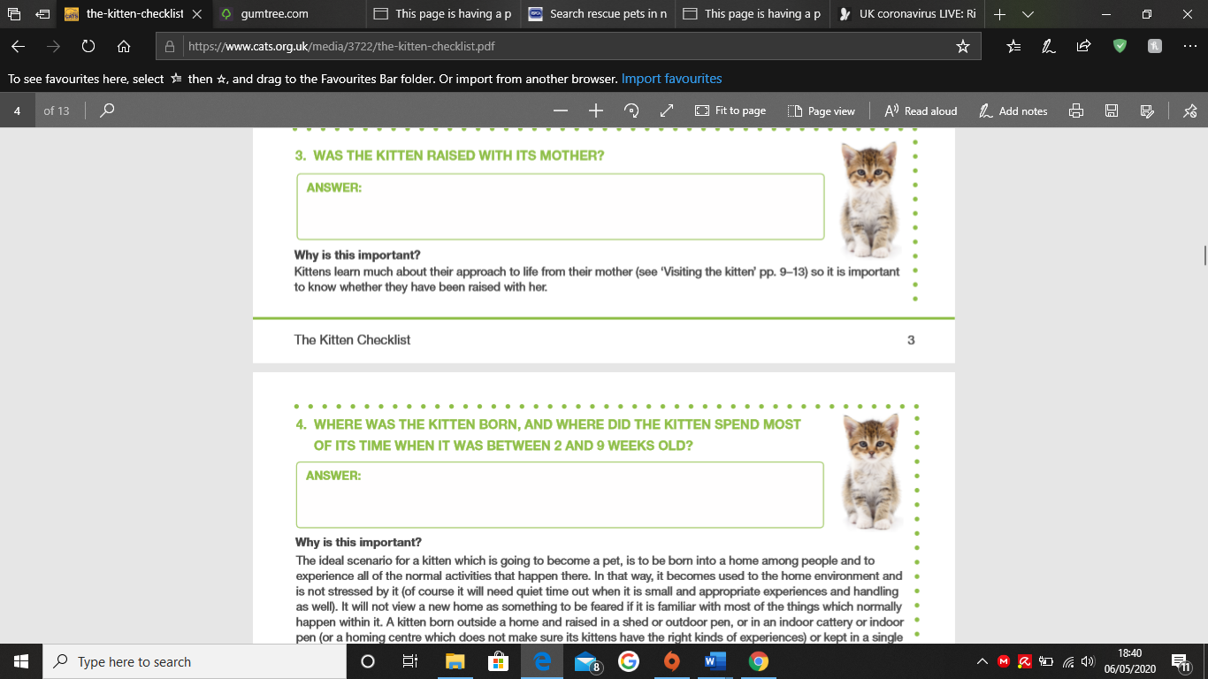

Figure 6: Cats.org Pre-purchase Checklist Question 3-4

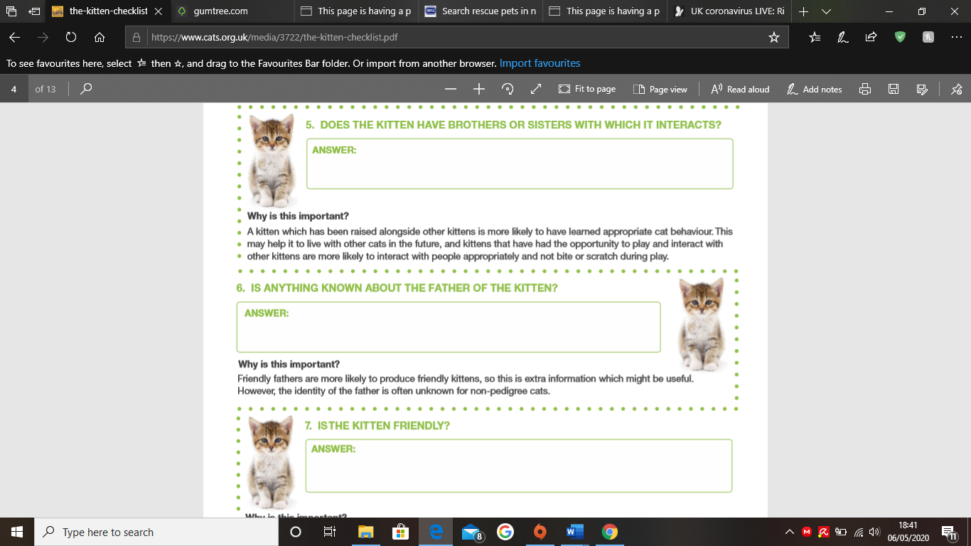

Figure 7: Cats.org Pre-purchase Checklist Question 5-6-7

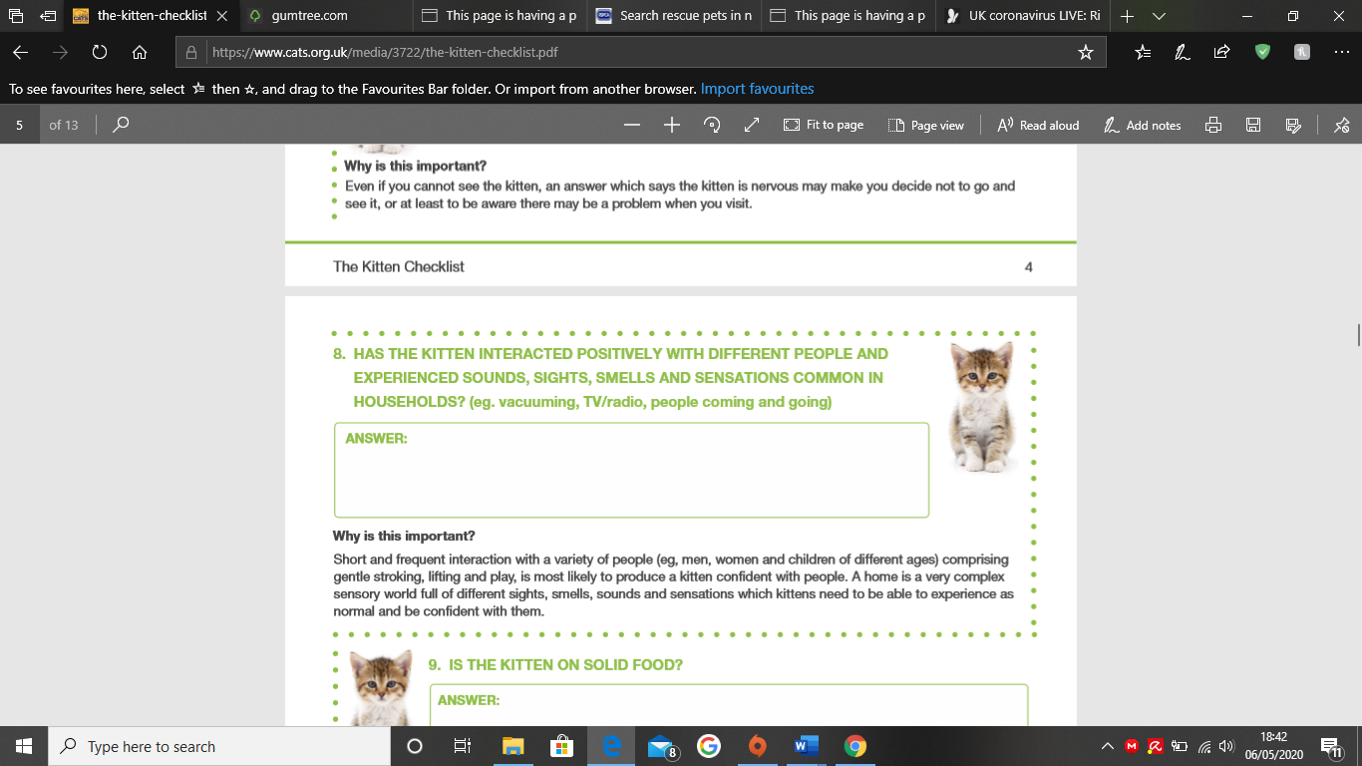

Figure 8: Cats.org Pre-purchase Checklist Question 8-9

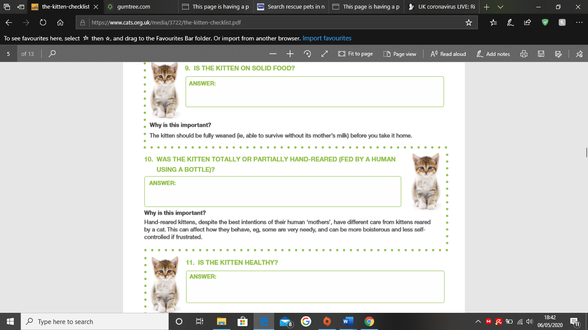

Figure 9: Cats.org Pre-purchase Checklist Question 9-10-11

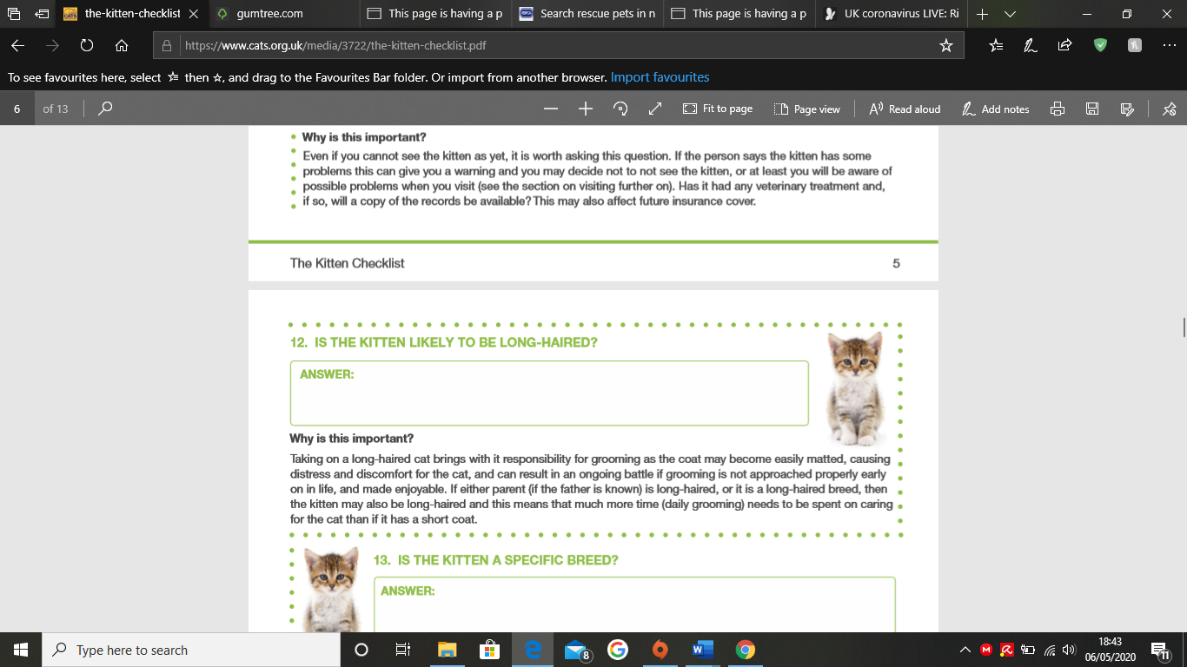

Figure 10: Cats.org Pre-purchase Checklist Question 12-13

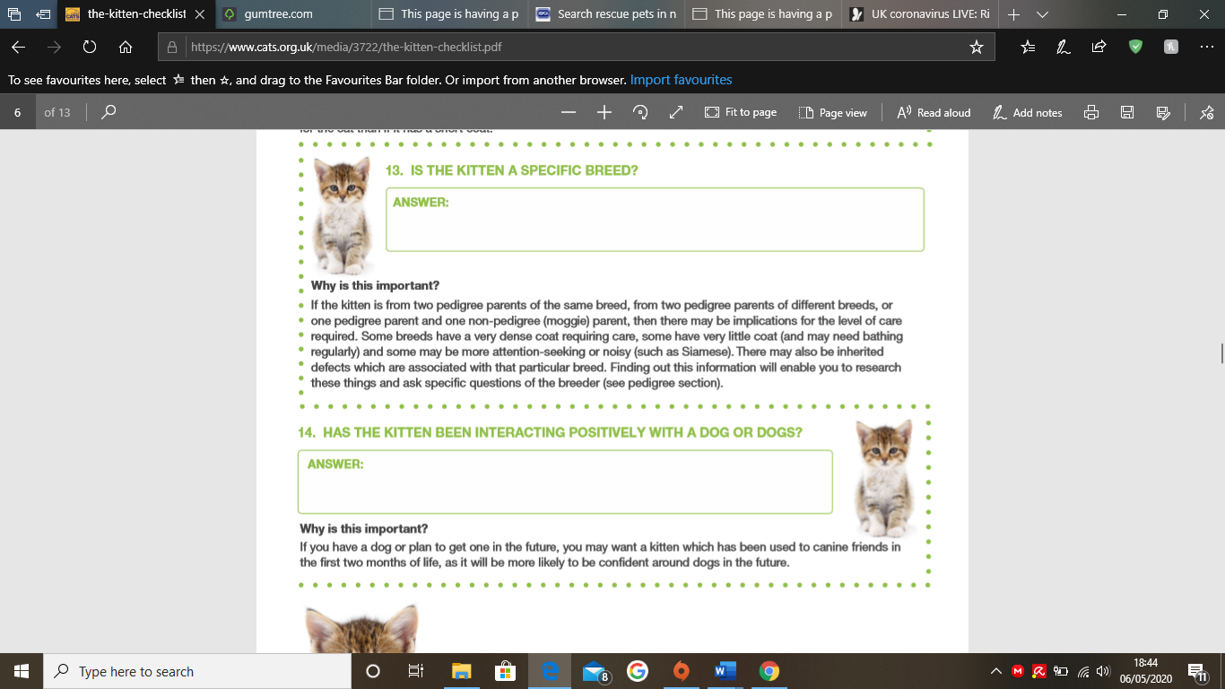

Figure 11: Cats.org Pre-purchase Checklist Question 13-14

The questions revolve around the birth of the kitten and its time with its parents and siblings, knowledge of father, socialisation, reaction to people, noise and other animals, and finally, the health and diet of the kitten and breed.

The screenshot below shows a description of a kitten, however, it is brief and does not meet expectations of a buyer regarding the kitten, such as if the buyer needs to get it wormed and neutered, if it’s up to date with its vaccinations or if the buyer is able to see the mother too. These kinds of questions are important because it demonstrates if the kitten has been raised alongside it’s mother for the first 8 weeks. In addition, it would be helpful to know if the kitten has had its vaccinations so the buyer will know if there are any additional charges on top of the money they are paying for the kitten. (Gumtree, 2020)

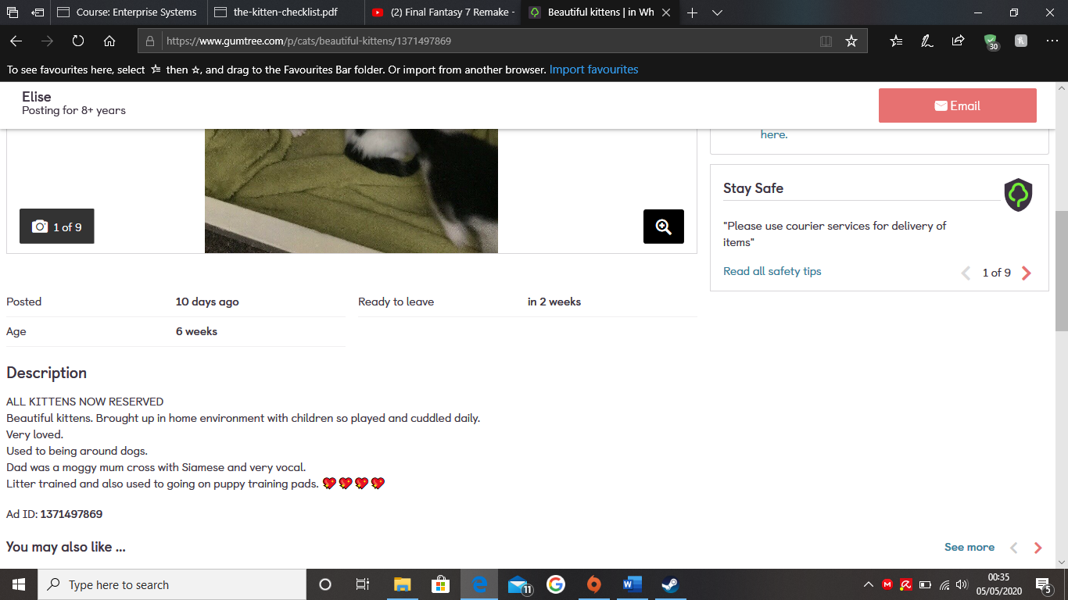

Figure 12: Gumtree Listing of Kittens

# Methodology

This major project used the Kanban Methodology in order to manage the project. Kanban is a method which is used to visualise the workflow in relation to all aspects of product development, in this case, the creation of the system for buying and selling cats online. The Kanban method looks at the product lifecycle and ensures an enhanced workflow once a stage is completed and the product moves onto the next phase. Kanban has been designed to be used with teams however, in the case of this project, there was only two people involved.

Kanban was selected above other agile methodologies for example, Scrum, because it was best matched to the nature of the project. Kanban allows no prescribed roles which means that the person who is working on the project can undertake several roles; they would need to work on all parts of the project rather than focus on a specific project role. Another reason why Kanban was used was because it allows the person to provide continuous updates on the project, and permits them to work at their own pace rather than having to rush, in order to meet a timed milestone. The final reason why Kanban was used was because if something went wrong with the project, there would be time to go back and fix it before the project was completed, unlike the Scrum methodology, where if a mistake was made, there would not be time to go back and rectify the issue.

<https://resources.collab.net/agile-101/what-is-kanban>

## 3.1 Qualitative Interviews

The qualitative research methodology used was semi structured interviews in order to collect information from people to get an insight about how people feel when buying a cat online, and to ask how the purchasing process could be improved, in order to provide a user friendly interface and detailed information for potential customers to make a purchase. The questions were designed around how people feel when online purchasing and whether they would recommend buying a cat online or not, and whether enough information was provided for them in order to make a safe purchase. The participants for the interviews ranged from family members to close friends whose experiences, and opinions were explored about how they would like to buy a cat online to be a simpler process. In order to contact them, the family members were at home so they could be easily interviewed, the close friends, due to the coronavirus, had to be contacted using the phone. The family members were interviewed at home by recording the interview on the laptop and close friends were interviewed by using Facebook Messenger.

## Project Plan

Table 1: Project Plan Milestones

| Project Title: Buying and selling a cat online | Start Date | End Date | Progress to date /Evidence of Achievement |
| --- | --- | --- | --- |
| **Milestones:** |  |  |  |
| **Feasibility** | **12/02/2020** | **22/05/2020** | Scope: Using a Access database to build the back end of the website and to store data in it while uploading it to the cloud |
| **Initial Plan** | **17/02/2020** | **14/05/2020** | The initial plan is to carry out research into what areas can be improved by providing interviews with people who have owned a cat or have experienced buying a pet online and by using that data, we can determine what can be improved and what can be implemented based on that feedback. |
| **Requirements Determination** | **13/03/2020** | **15.03/2020** | Microsoft Access |
| **Methodology** | **14/03/2020** | **15/03/2020** | Kanban  Project Plan |
| **Revise Plan** | **15/03/2020** | **22/05/2020** | Update project plan as necessary |
| **Execution** | **12/04/2020** | **19/05/2020** | Development of application |
| **Testing** | **19/05/2020** | **22/05/2020** | The testing was undertaken by peers to test the application to make sure the features worked as intended and to see if the interface was user friendly and if it had accomplished the aim of the project |
| **Reflection** | **22/05/2020** | **22/05/2020** | How well the project went, what went well and what could be improved |
| **Documentation** | **22/05/2020** | **22/05/2020** | Final report and black box testing |

Table 2: Project Plan Gantt Chart

| Project Title: Buying and selling a cat online | 03/02 | 10/02 | 17/02 | 24/02 | 02/03 | 09/03 | 16/03 | 23/03 | 30/03 | 06/04 | 13/04 | | 20/04 | 27/04 | 04/05 | 11/05 | 18/05 |
| --- | --- | --- | --- | --- | --- | --- | --- | --- | --- | --- | --- | --- | --- | --- | --- | --- | --- |
| Tasks/Milestones |  |  |  |  |  |  |  |  |  |  |  |  | |  |  |  |  |
| **Milestones** |  |  |  |  |  |  |  |  |  |  |  |  | |  |  |  |  |
| **Research online/literature** |  |  |  |  | 08/03 |  |  |  |  |  |  | |  |  |  |  |  |
| **Feasibility** |  |  |  |  |  |  |  |  |  |  |  | |  |  |  |  | 22/05 |
| **Initial Plan** |  |  |  |  |  |  |  |  |  |  |  | |  |  |  | 14/05 |  |
| **Requirements Determination** |  |  |  |  |  | 15/03 |  |  |  |  |  | |  |  |  |  |  |
| **Methodology** |  |  |  |  |  | 15/03 |  |  |  |  |  | |  |  |  |  |  |
| **Revise Plan** |  |  |  |  |  |  |  |  |  |  |  | |  |  |  |  | 22/05 |
| **Execution** |  |  |  |  |  |  |  |  |  |  |  | |  |  |  | 19/05 |  |
| **Testing** |  |  |  |  |  |  |  |  |  |  |  | |  |  |  | 19/05 |  |
| **Reflection** |  |  |  |  |  |  |  |  |  |  |  | |  |  |  |  | 22/05 |
| **Documentation** |  |  |  |  |  |  |  |  |  |  |  | |  |  |  |  | 22/05 |

# Development

Developing the application

Firstly, to develop the application it was necessary to create a table for cats which contained their basic information, it was also necessary to incorporate the questions from cats.org into the form for kittens. The questions will be answered using yes or no tabs and, in addition a long text format will be added to some of the questions as they may require words rather than a simple yes or no answer.

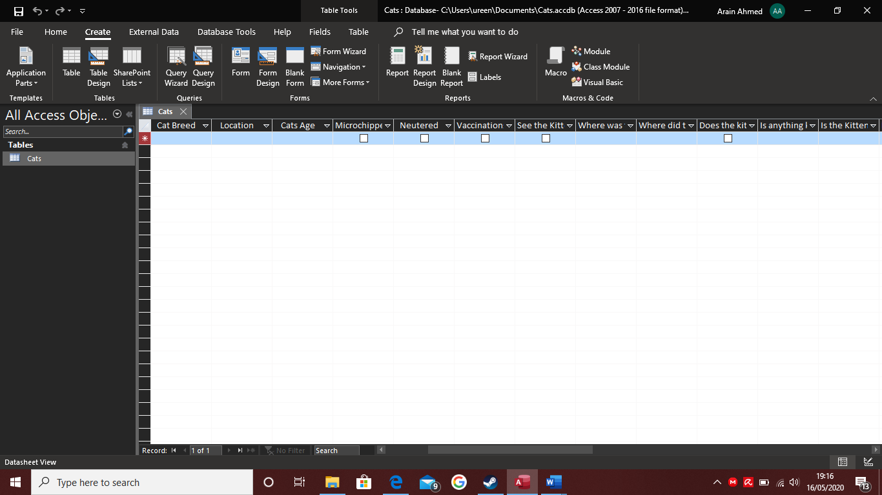

Figure 13: A Blank Cats Table

Once the table was completed a form had to be created in order to aid data entry and to visualise the form to illustrate what the customers would view.

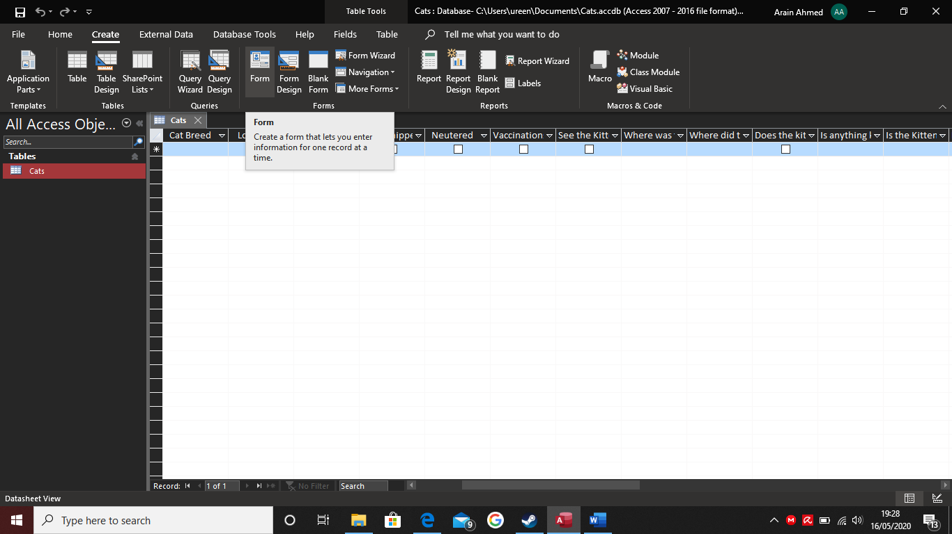

Figure 14: Selecting The Form Option

In the screenshot below shows the appearance of the form when it is created, however since there is no data, the form is blank. The boxes needed to be rearranged so that they fitted onto one page.

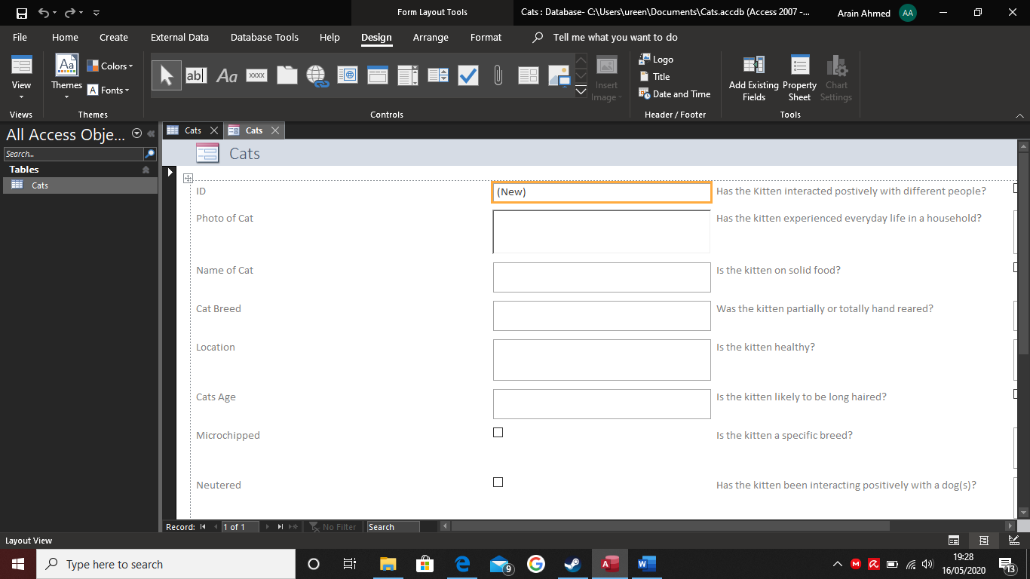

Figure 15: A Blank Form Created

In the screenshot below the data has been inputted and a photo of a kitten has been added, this is only one half of the data as there are more questions below which the buyer needs to see.

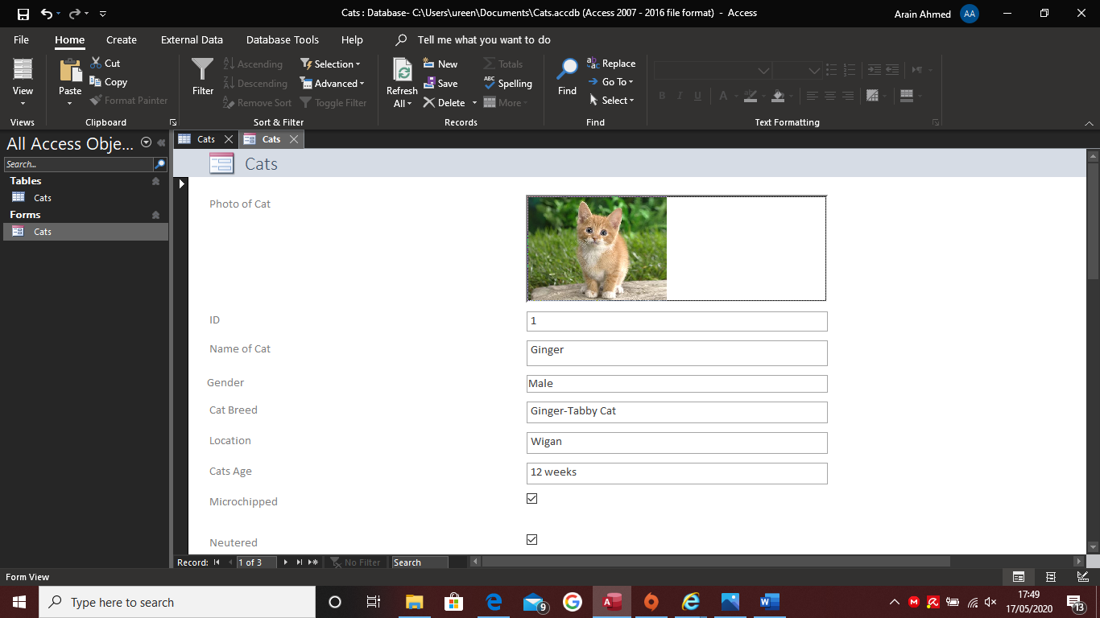

Figure 16: A Form with data inside of it

In the screenshot below, there are more questions which a buyer will need to think about when they purchase a kitten, these questions are from the cats.org kitten checklist which were required for additional information, as other websites or listings left out this type of information. This enables the purchaser to consider a number of aspects before buying the kitten.

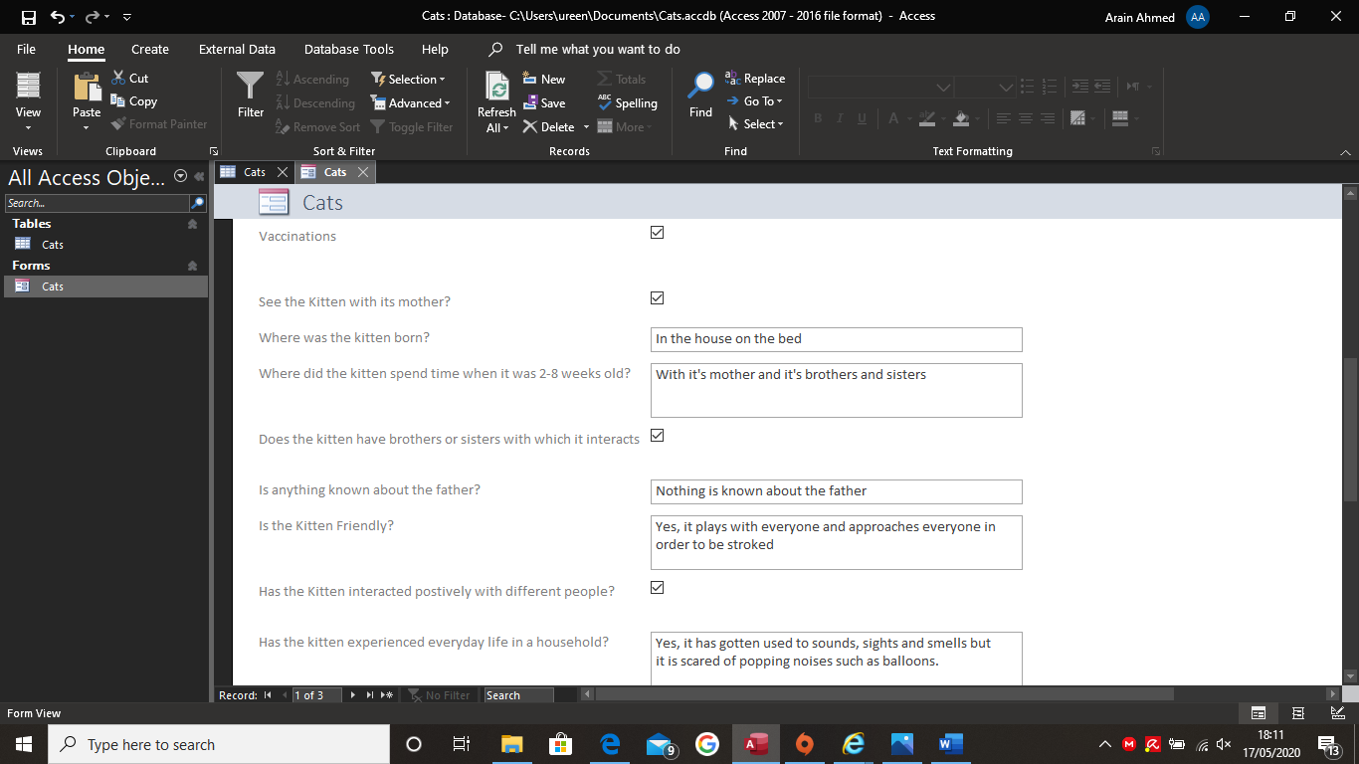

Figure 17: The second half of the form

The screenshot below shows the final section of the information on the form, the reason why it was so long is because there were a lot of questions to consider when buying a kitten. The information to consider included what to expect from the kitten and additional charges and costs.

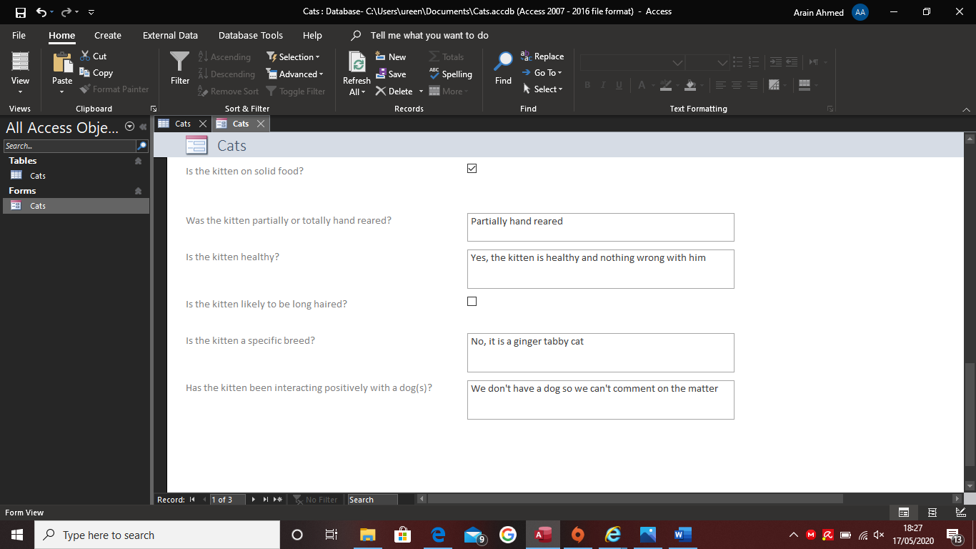

Figure 18: The last part of the form

In the screenshot below the property sheet needed to be opened in order to make the adjustments to the form before it can be opened in a new window in full view rather than being opened in Access. In order to do this, there was a square icon that was underneath the cats tab to open the property sheet and to click on the “other” tab in order to change a few settings to confirm the changes. The next screenshot will show the changes that were made.

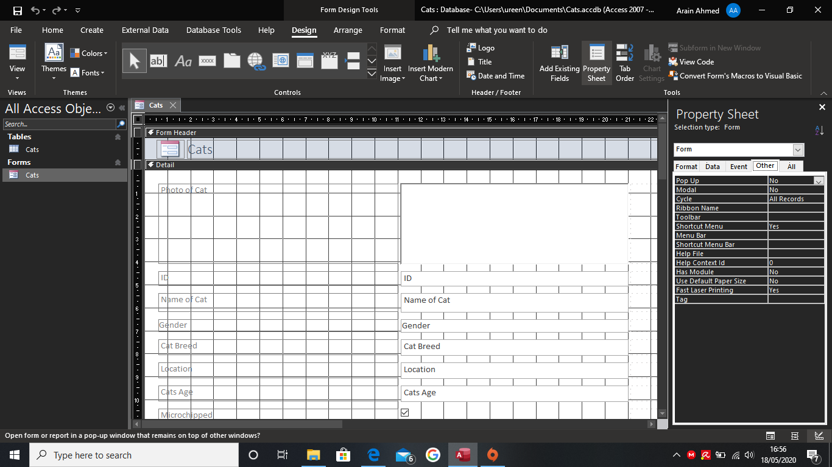

Figure 19: Opening the property sheet for the Cats form

In this screenshot the settings for “Pop Up” have been changed to “Yes” in order to make the form open up in a new window.

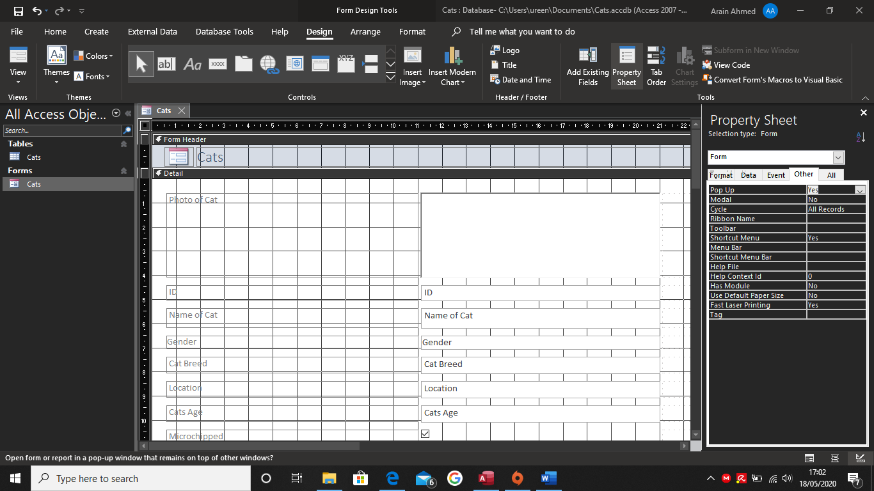

Figure 20: The Property Sheet having the settings changed

In this screenshot the “Event” tab was selected and the “On Load” selection was chosen which means when the form was accessed within Access, it would open up in a new window, the three dots icon was chosen and the code builder was selected, as a command was required in order to make the form appear in an additional window.

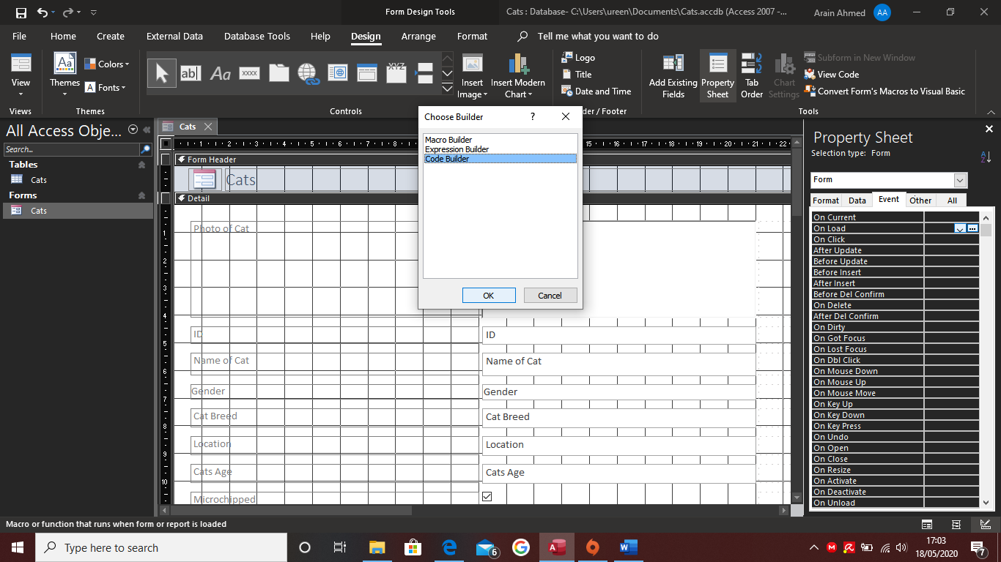

Figure 21: The On Load Builder Opened To Change The Settings

After the previous step, a new window opens up which reveals the code running in the background.

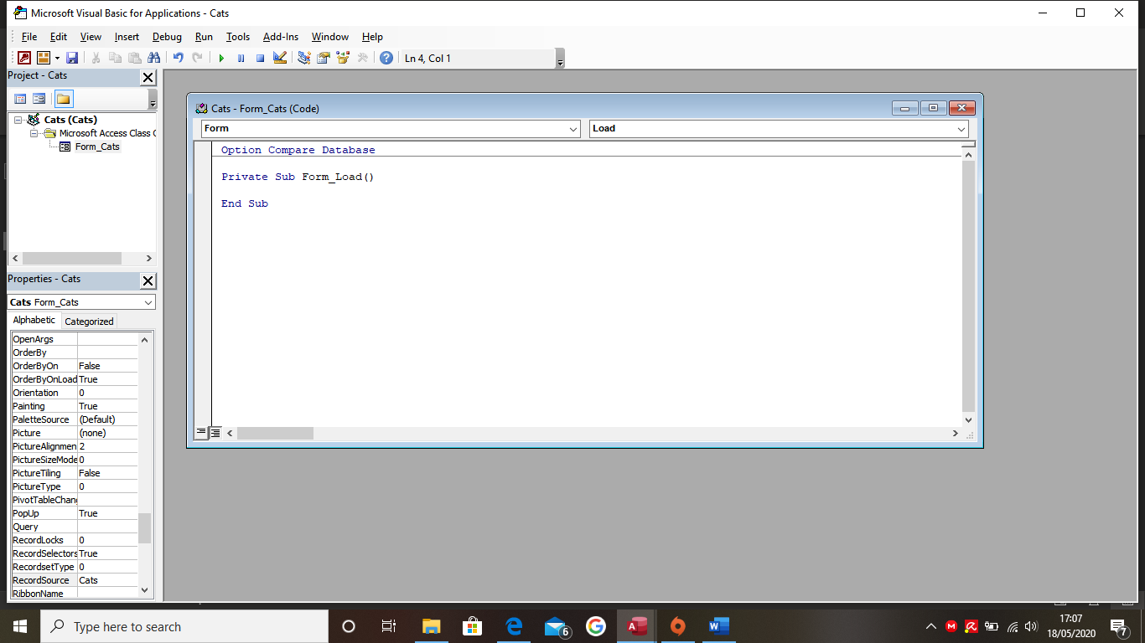

Figure 22: The Code Builder Opened But Unaltered

In this step, the code “DoCmd.Maximize” had to be inputted in order for the form to open in full view. Once this was completed, the program had to be saved and closed in order to access the form for testing.

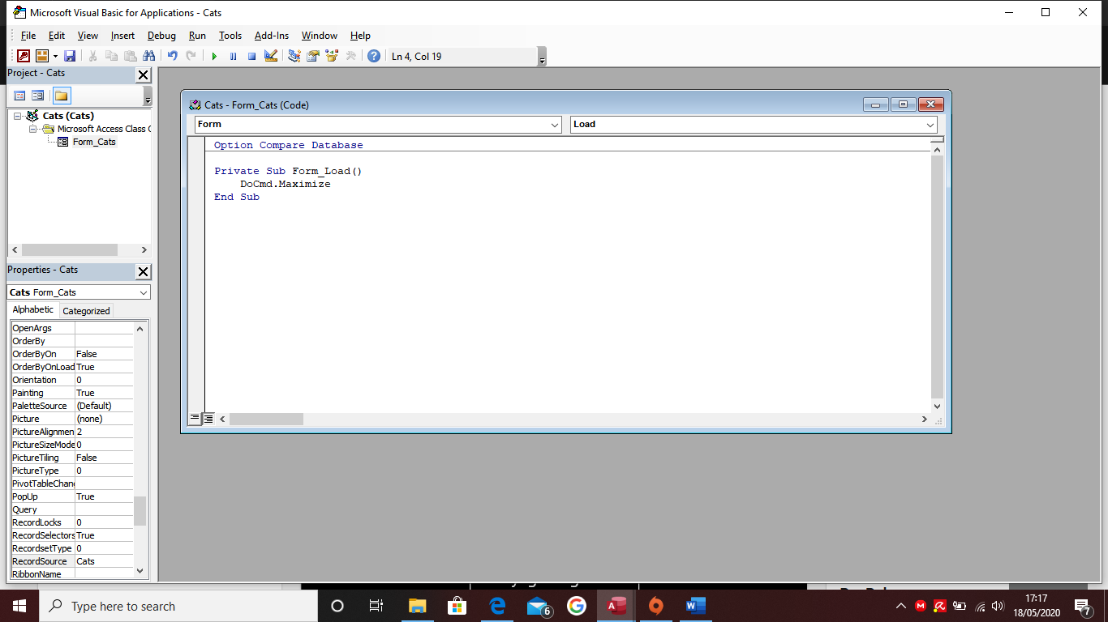

Figure 23: The Code Builder Changed With The Correct Code

The final appearance of the form is as below. Whenever the form is accessed through Microsoft Access, the window will open up and permit the user to input data which is saved in the table.

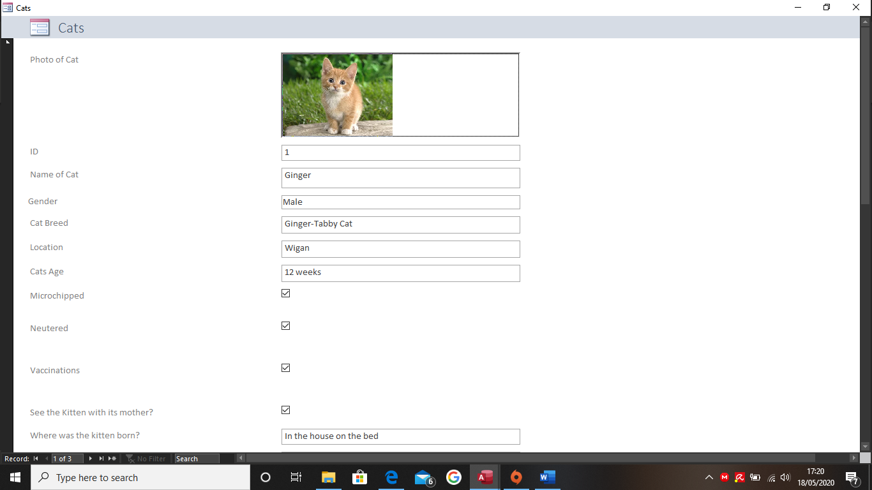

Figure 24: The Form Now Available In Full View

In this section below two tables were required, and a relationship was established between the two using a primary key and a foreign key. This database required an owners table and a cats table. For this to work, the owner table had to be created in order to link with the cats table, this required an owner ID in order to save data.

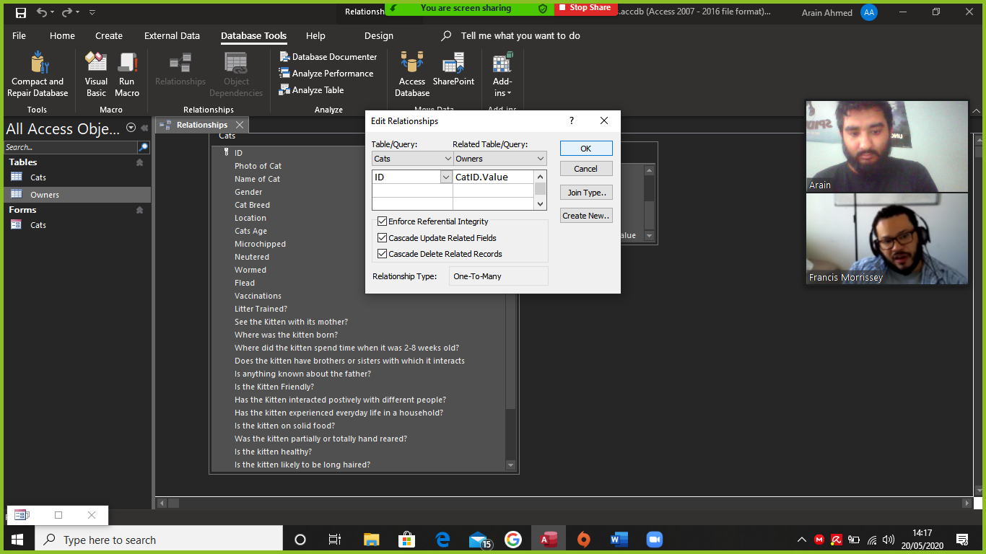

Figure 25: The Relationships Being Shown Between The Tables

10 forms were required in order to present a variety of data. The query created below was to calculate how many female cats there are for sale. In order to do this, the cats table would need to be selected in the table box and the word “Female” would need to be typed in the criteria box, since this is what the query needed to find.

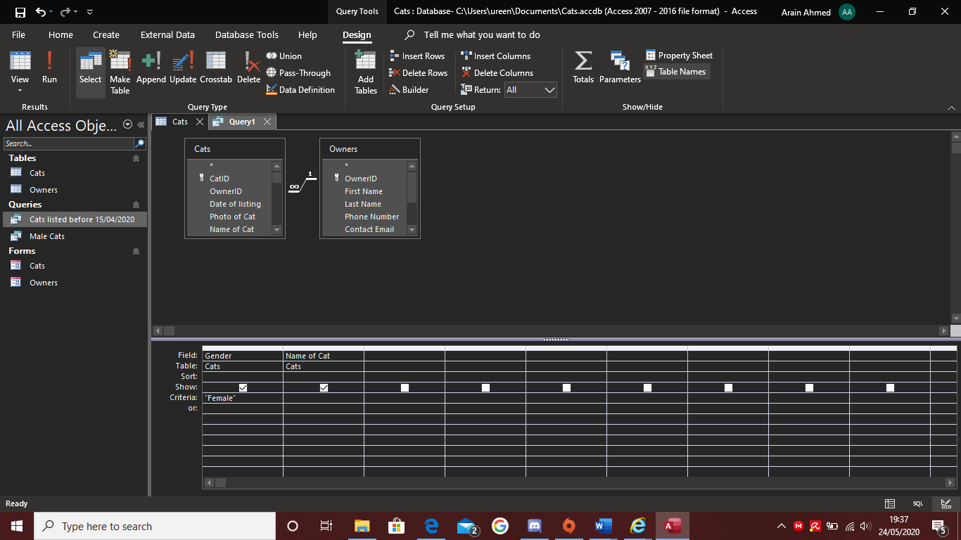

Figure 26: A Query Being Made By Using Female Cats

This is the query that appears when the run option is selected. In the screenshot below it shows all the female cats that are in the database and their names.

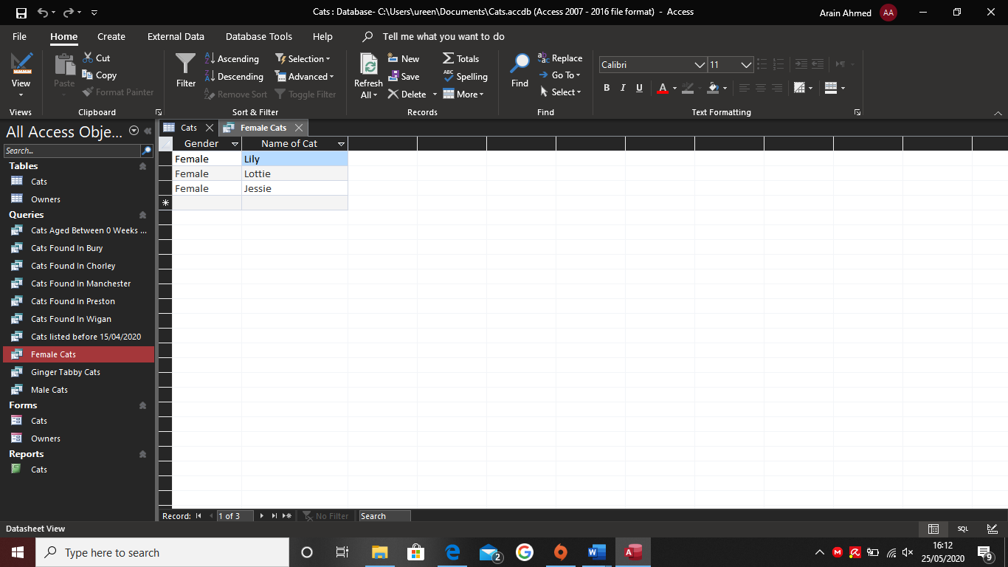

Figure 27: The Query Completed With The Female Cats Being Shown

In the screenshot below a report was created in order to show the important information about the owners and cats. The report illustrates the owners and cats unique ID, the breed of cat, which is the type of cat and their sex.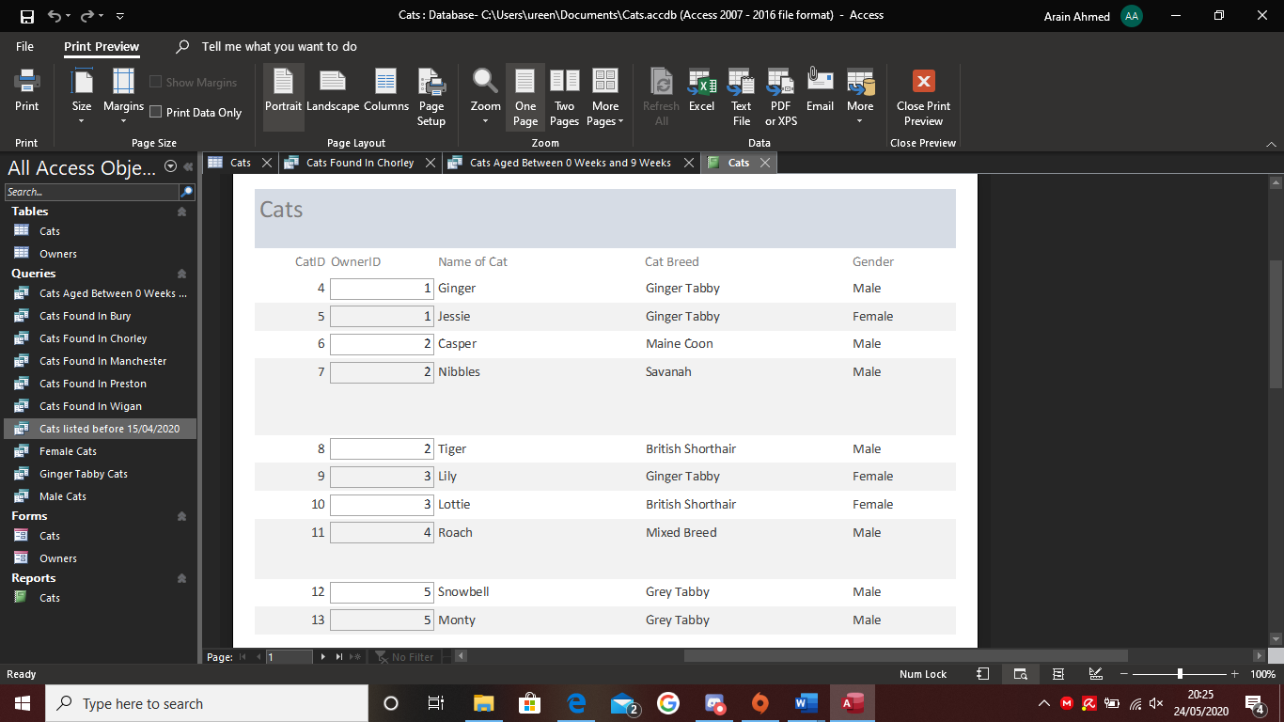

Figure 28: A Report Completed Showing CatID, OwnerID, Cat Breed and Gender

## Normalisation

According to (Guru99, n.d.), Normalisation is a database design technique that is used to remove redundant data and separates large tables into smaller tables by dividing the data between the two.

This has been actioned in the database by splitting the owner and cats’ tables, so they do not make the table bloated and removes redundant data, such as address and location from being inputted twice. The way the two tables are connected are by primary and foreign keys, which means there is a unique ID system in both tables; one table will have a link to the other table, so whenever data is inputted from that table, it will then transfer to the other table.

# Testing

Table 3: White Box Testing For Application

|  |  |  |  |
| --- | --- | --- | --- |
| What happened | Justify Why | Predicted Result | Actual Result |
| Opened Microsoft Access | I needed to access the application through this program | Microsoft Access opened | Microsoft Access opened |
| Accessed the Cats Database | This is the application I had been working on | The database opened | The database opened |
| Opened the Cats Form | I need to see if the form opens in full view without any issues | The form opened with no issues | The form opened with no issues |
| Check all the data that is in the form | I needed to see if everything was present and to make sure no data was missing | All the data appeared, and the right images popped up for the kittens | All the data appeared, and the right images popped up for the kittens |
| Opened the Owners Form | I needed to see if this does the same as the cats form did | The form opened with no issues | The form opened with no issues |
| Check all the data that is in the form | I needed to see if everything was present and to make sure no data was missing | All the data appeared | While the data did appear, there was an issue with the CatID as none appeared for the first 3 owners, but the first 2 kittens appeared for the last 2 owners |
| Input a new data into Owners | I needed to test to see if the data saved to the database and the database required an owner first before I input new data for the cat | New data was created for Owner | New data was created for Owner |
| Input a new data into Cats | I needed to test to see if the data saved to the database | New data was created for Owner | New data was created for Owner |
| Place a photo of the kitten | The database required a photo of the kitten so the buyer would know what the cat would look like | The photo has been placed inside and when the user moves through the forms, the photo appeared again | The photo has been placed inside and when the user moves through the forms, the photo appeared again |
| Making a query for the database | I needed to know if I could store data into queries and when new data was added to the database, it would extract the same data and place it into the query rather than the user doing it manually. | The query was created with the key information required | The query was created with the key information required |

## Feedback

After showing the program to a member of the family, she gave me positive feedback but also mentioned that the program is lacking features that is mentioned on other online websites such as wormed and flead, these would be important to know because the buyer would have to make sure there is not any additional charges in order to get the kitten done for those two. There was another feature that was lacking which was knowing whether the cat interacts positively with other cats which are different from it’s family as the kitten could be aggressive towards other cats, this would be helpful to know just in case the buyer decides to have another kitten in the future or has a cat at home.

The interface was plain and the family member who I shown it to was happy with the way it looked and couldn’t find anything wrong with it. I could not ask anyone else unfortunately due to the coronavirus outbreak so I could not present the program to anyone else without them testing it.

# Critical Reflection

The following critically evaluates the process of delivering the project, ‘How to make buying a cat online easier’. It reflects on several key factors which impacted on the successful delivery of the project. The first key factor was time management; however, I did not manage my time very effectively due to conflicting assignments which I had to prioritise before I could focus solely on this project. I did use the time I had well and made the best program I could under the circumstances and I am proud of how it turned out, especially because of the coronavirus impact. COVID-19 pandemic spread throughout the country and halted and continues to halt everyday life. It impacted the progression of the project because I usually work at the university rather than at home however, since it has been closed I have had to work at home which has been an issue for me, as I usually become easily distracted by my surroundings. The best way to work around this problem was using Zoom, I had meetings with my tutors and my supervisor in order to progress the project.

Under the circumstances, project management was key since there was always a schedule to follow, whenever I was given tasks by my supervisor and whenever those tasks had been completed, I would be given new ones in order to progress the project and make the database more technical. My supervisor was extremely supportive in this case, as he was always available to help, whenever I had an issue or a question, he would help out and made sure the problem was solved. However, due to the conflicting assignments I had, I did not access him as much as I would have liked to, which resulted in not receiving enough input; the input I did receive with the project was very helpful. The interviews were another key factor which impacted the project because without them, I would not have been able to progress.

The responses I got from everyone were helpful and informed me about what people expected when buying a kitten online. However, due to the Coronavirus, I could not record everyone’s interview due to the social distancing rules that were implemented. I contacted participants by using Facebook Messenger in order to obtain the feedback. The feedback received from the interviews were extremely helpful as I managed to build a database with the information I obtained about what buyers would like to know when buying cats online; although improvements can be made, the application performs the tasks I designed it to do.

The user interface of the project is simple and clear which means that users should not find it difficult to use, the design was plain because I wanted to minimise distractions while the users were filling the form out. One thing I was surprised by was the amount of support there was for Microsoft Access, this was extremely helpful as there was a lot of information on how to perform certain tasks, the user interface was simple and friendly compared to other database programs.

However, using Microsoft Access did come with issues such as it’s limitations. The main limitation with the program is that the front end was only in Form View which means that it cannot be viewed in an internet browser but only within Access. Another limitation was the lack of coding, as everything is automated, this may be frustrating to some as they prefer to code, but for me personally this was good as I could make less mistakes, however the mistakes are hard to find in order to identify the problem since I cannot view the code. For future development, I would like to implement a help button below some questions on the form, as it may give a more elaborate explanation as to why these questions are being asked. Further improvement is to implement the program into an actual browser, as it does have the potential of becoming a useful program to help cat owners and those who would love to buy a kitten.

# Conclusion

In Conclusion, considering the impact of COVID-19 and the fact I had several assignments due in simultaneously, I am proud about how the project developed, and I am very pleased about the final product. On reflection, I feel in some ways Coronavirus has helped me focus more on my academic writing due to having to remain at home, I have been able to concentrate, without having to go to work. I have missed having access to university as I could have used more input and would have seen my tutors or supervisor more since I would not have to schedule a meeting on different days during the week. Overall, I think I have improved compared to where I was last year in my academic studies and I have gained more knowledge this year compared to last year due to the support I received.

# Bibliography

Group, T. C., n.d.. *The Kitten Checklist.* [Online]   
Available at: https://www.cats.org.uk/media/3722/the-kitten-checklist.pdf  
[Accessed 12 April 2020].

Gumtree, 2020. *Beautiful Kittens.* [Online]   
Available at: https://www.gumtree.com/p/cats/beautiful-kittens/1371497869  
[Accessed 5 May 2020].

Guru99, n.d.. *What is Normalization? 1NF, 2NF, 3NF & BCNF with Examples.* [Online]   
Available at: https://www.guru99.com/database-normalization.html  
[Accessed 25 May 2020].

RSPCA, 2020. *Rehome a pet.* [Online]   
Available at: https://www.rspca.org.uk/findapet?p_p_id=petSearch2016_WAR_ptlPetRehomingPortlets&p_p_lifecycle=1&p_p_state=normal&p_p_mode=view&_petSearch2016_WAR_ptlPetRehomingPortlets_action=search#onSubmitSetHere  
[Accessed 5 May 2020].

# Appendices

## Proposal Form

**SEC6101 Undergraduate Project**

**Project Proposal Form**

**2019-20 Semester 2**

**Student Details**

|  |  |
| --- | --- |
| Name: | Arain Ahmed |
| Student Number: | 1802877 |
| Email: | aa10crt@bolton.ac.uk |
| Degree Pathway: | Computing |

**Project Details**

|  |  |
| --- | --- |
| Proposed Title: | How to make buying a cat online easier |
| Allocated Supervisor: | Francis Morrisey |
| What are the objectives of your project? | |
| To make ordering a cat online easier by giving as much description as they can about the animal they are selling and to let the buyer know what they can expect from the feline. | |
| What problems and/or questions will your project address? | |
| This will solve the issue people have by ordering a cat online as people are weary of doing so because of information they do not know beforehand and because they end up paying more for the animal than they originally planned. | |
| What data will you need to meet your objectives and how will you gather it? | |
| Interviews with people who have owned or love cats and come up with well-thought out questions that can get useful data in order to proceed the project forward. | |
| What hardware, software and other resources will you need? | |
| Microsoft Access  Continued overleaf… | |
| Will any of these resources cost money? If you answer ‘yes’ please give details. | |
| No | |
| Will your project involve human participants? If you answer ‘yes’ please give details. | |
| Yes, I will for the interview stage as I need people’s opinion about how they feel about ordering a cat online and if they have, what was their experience like and how I can improve it for the better. | |
| What do you think makes your project ‘academically challenging’? | |
| * Increase my knowledge in databases * Learn how to store data * By doing extensive research on the web and in person with interviews | |
| Have you already started work on your project (e.g. background research, technical work, etc.)? Provide brief details if you have. | |
| Yes, I have started this project with Francis and did some background research on other websites and what details they give about the cat that is being sold | |
| Have you discussed your ideas with any members of staff? If ‘yes’ please give details. | |
| Yes, I have discussed this project with Francis Morrissey | |
| Use this space for anything not covered by the above questions, e.g. thoughts, concerns, etc. | |
|  | |

## Research Ethics Checklist



**Form RE1**

**Research Ethics Checklist**

May 2018

This checklist should be completed for every research project which involves human participants. It is used to identify whether a full application for ethics approval needs to be submitted.

**Before completing this form, please refer to the University Code of Practice on Ethical Standards for Research Involving Human Participants**. The principal investigator and, where the principal investigator is a student, the supervisor, is responsible for exercising appropriate professional judgment in this review.

***This checklist must be completed before potential participants are approached to take part in any research.***

**Section I: Applicant Details**

|  |  |
| --- | --- |
| 1. Name of Researcher (applicant): | Arain Ahmed |
| 2. Status (please click to select): |  |
| 3. Email Address: | aa10crt@bolton.ac.uk |
| 4a. Contact Address: |  |
| 4b. Telephone Number: | 07715425326 |

**Section II: Project Details**

|  |  |
| --- | --- |
| 5. Project Title: | How to make buying a cat online easier |

**Section III: For Students Only:**

|  |  |
| --- | --- |
| 6. Course title and module name and number where appropriate  School/Centre: | Undergraduate Major Project  University of Bolton |
| 7. Supervisor’s or module leader’s name: | Francis Morrisey |
| 8. Email address: |  |
| 9. Telephone extension: |  |

***Declaration by Researcher (Please tick the appropriate boxes)***

|  |  |
| --- | --- |
| ✔ | I have read the University’s Code of Practice |
| ✔ | The topic merits further research |
| ✔ | I have the skills to carry out the research |
| ✔ | The participant information sheet, if needed, is appropriate |
| ✔ | The procedures for recruitment and obtaining informed consent, if needed, are appropriate |
| ✔ | The research is exempt from further ethics review according to current University guidelines |
| ✔ | Where relevant, I have read the ethical guidelines of the regulatory body that is relevant to my discipline and verify that the research adheres to these guidelines |

|  |
| --- |
| **Comments from Researcher, and/or from Supervisor if Researcher is Undergraduate or Taught Postgraduate student:** |
|  |

**Section IV: Research Checklist**

**Please answer each question by ticking the appropriate box**

|  |  |  |
| --- | --- | --- |
|  | **YES** | **NO** |
| 1. Will the study involve participants who are particularly vulnerable or who may be unable to give informed consent (e.g. children, people with learning disabilities, emotional difficulties, problems with understanding and/or communication, your own students)? |  | ✔ |
| 2. Will the study require the co-operation of a gatekeeper for initial access to the groups or individuals to be recruited (e.g. students at school, members of self-help group, residents of nursing home)? |  | ✔ |
| 3. Will deception be necessary, i.e. will participants take part without knowing the true purpose of the study or without their knowledge/consent at the time (e.g. covert observation of people in non-public places)? |  | ✔ |
| 4. Will the study involve discussion of topics which the participants may find sensitive (e.g. sexual activity, own drug use)? |  | ✔ |
| 5. Will drugs, placebos or other substances (e.g. food substances, alcohol, nicotine, vitamins) be administered to or ingested by participants or will the study involve invasive, intrusive or potentially harmful procedures of any kind? |  | ✔ |
| 6. Will blood or tissues samples be obtained from participants? |  | ✔ |
| 7. Will pain or more than mild discomfort be likely to result from the study? |  | ✔ |
| 8. Could the study induce psychological stress or anxiety or cause harm or negative consequences beyond the risks encountered in normal life? |  | ✔ |
| 9. Will the study involve prolonged or repetitive testing? |  | ✔ |
| 10. Will financial inducements (other than reasonable expenses and compensation for time) be offered to participants? |  | ✔ |
| 11. Will participants’ right to withdraw from the study at any time be withheld or not made explicit? |  | ✔ |
| 12. Will participants’ anonymity be compromised or their right to anonymity be withheld or information they give be identifiable as theirs? |  | ✔ |
| 13. Might permission for the study need to be sought from the researcher’s or from participants’ employer? |  | ✔ |
| 14. Will the study involve recruitment of patients or staff through the NHS? |  | ✔ |

If ALL items in the Declaration are ticked AND if you have answered NO to ALL questions in Section IV, **send the completed and signed** (in ‘Declaration’) **RE1 to your School/Centre Research Ethics Officer** for information. You may proceed with the research but should follow any subsequent guidance or requests from the School/Centre Research Ethics Officer or your supervisor/module leader where appropriate. Undergraduate and taught postgraduate students should retain a copy of this form and submit it with their research report or dissertation (bound in at the beginning). MPhil/PhD students should submit a copy to the Board of Studies for Research Degrees with their application for Registration (R1). **Work which is submitted without the appropriate ethics form will be returned unassessed.**

If ANY of the items in the Declaration are not ticked AND / OR if you have answered YES to ANY of the questions in Section IV, you will need to describe more fully in Section V of the form below how you plan to deal with the ethical issues raised by your research. **This does not mean that you cannot do the research, only that your proposal will need to be approved by the School/Centre Research Ethics Officer or School/Centre Research Ethics Committee or Sub-committee**. **When submitting the form as described in the above paragraph you should substitute the original Section V with the version authorized by the School/Centre Research Ethics officer.**

If you answered YES to ***question 14***, you will also have to submit an application to the appropriate external health authority ethics committee, after you have received approval from the School/Centre Research Ethics Officer/Committee and, where appropriate, the University Research Ethics Committee.

**Section V: Addressing Ethical Problems**

If you have answered YES to any of questions 1-13 please complete below and submit the form to your School/Centre Research Ethics Officer.

|  |
| --- |
| **Project Title** |
|  |

|  |
| --- |
| **Principal Investigator/Researcher/Student** |
|  |

|  |
| --- |
| **Supervisor** |
|  |

|  |
| --- |
| **Summary of issues and action to be taken to address the ethics problem(s)** |
|  |

**Declaration**

I understand that it is my responsibility to follow the University’s Code of Practice on Ethical Standards and any relevant academic or professional guidelines in the conduct of my project/study. **This includes providing appropriate information sheets and consent forms, and ensuring confidentiality in the storage and use of data**. If there is any significant change to the design or conduct of my project/study I will immediately notify the School/Centre Research Ethics Officer and I understand that this may require me to submit a new application for ethics approval.

Signed: Arain Ahmed Principal Investigator/Researcher

Approved: Andrew Parker DoS / Module Leader

Date: 03/2020

**For use by School/Centre Research Ethics Officer:**

* No ethical problems are raised by this proposed study - Retain this form on record
* Appropriate action taken to maintain ethical standards

Retain this form on record and return a copy of section V to Researcher

* The research protocol should be revised to eliminate the

ethical concerns or reduce them to an acceptable level,

using the attached suggestions

* Please submit School/Centre Application for Ethics Approval

(Form RE2(D))

* Please submit University Application for Ethics Approval

(Form RE2(U))

Signed:

Date:

## Project Diary

**30/01/2020**

Create an access database to rehome lost cats

Needs to be able to hold a lot of cat data, pictures and ID chip numbers

For next Monday, look at the project proposal and learn how to use access

Do a trial database in access for next Monday

Research how to put photos in access and also find 20 pictures of cats

Create a online cat database

Do a prototype database in access

Create a database based on 5 products from the kitchen

**03/02/2020**

Get photos of cats for a database

Make sure they are open source to avoid copyright

**06/02/2020**

Are there any examples of where to buy cats online?

How could they be improved?

Look at prototyping software project

Trial the features to make sure they work

Find the information online that can cover all of this

Go to LEAP online and learn how to reference and write academic papers

Are there any legal regulations about selling animals online (specifically cats)?

How will you advertise the cat?

How many cats am I going to put in the database and how will I test the website?

Let people try it out and let them review it via survey

**10/02/2020**

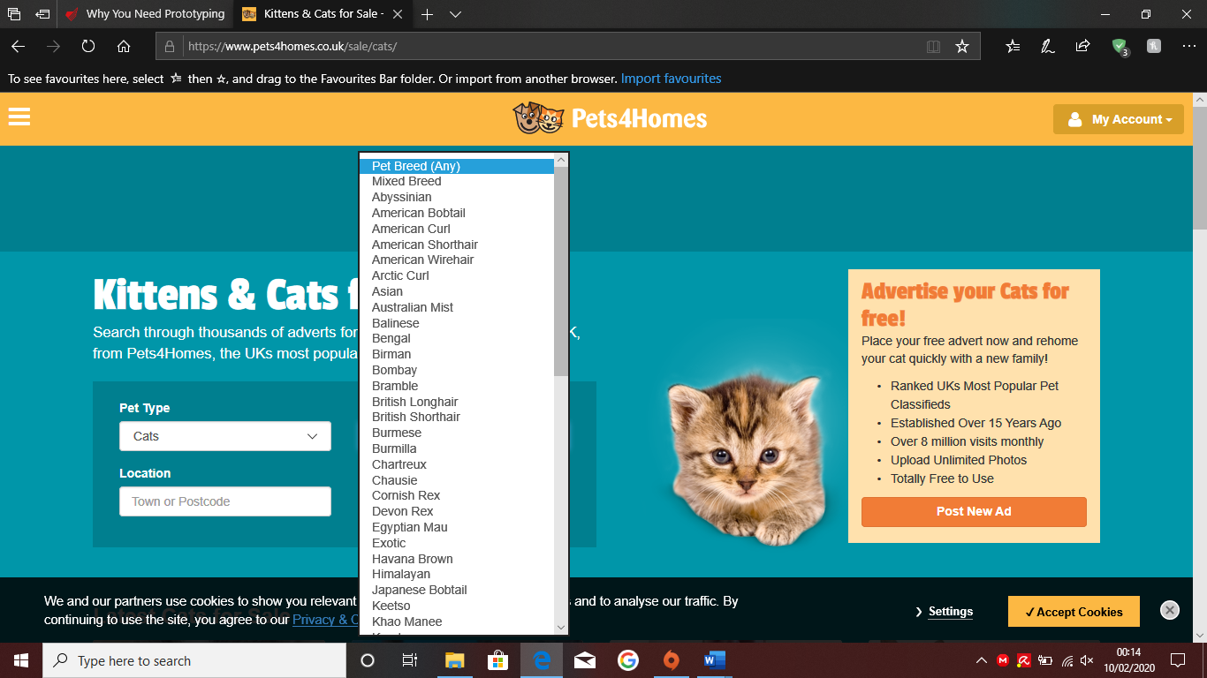

The photo shows what pet type you are looking for which could mean cat or dog, the pet breed is what type of animal it is. An example is the colour of the cat and the patterns on it which defines it’s breed. You also have the location so that means you can search closer to home than you may think.

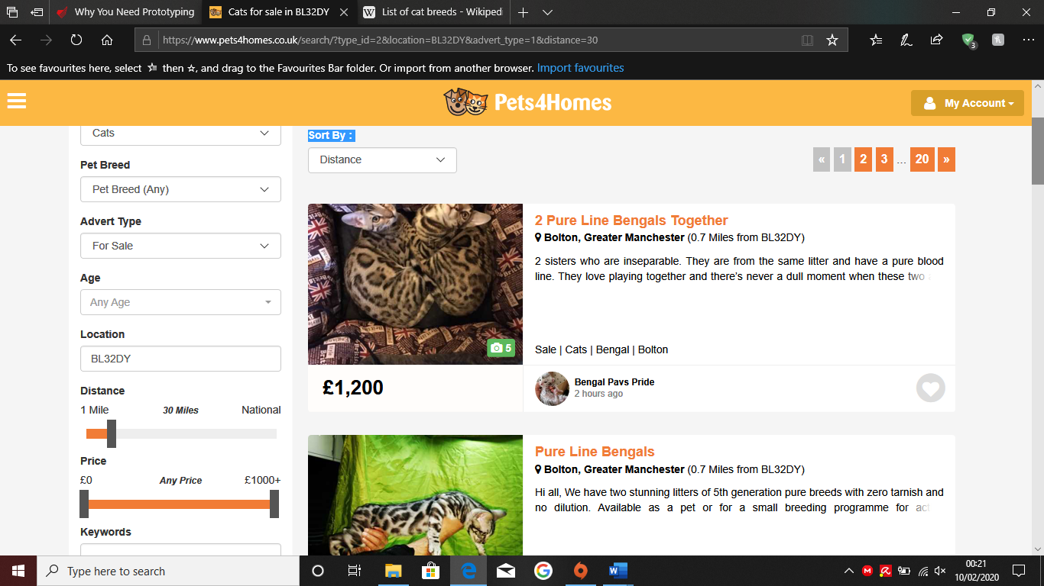

On this website on the left hand side, you can see more options such as the age of the animal if it is specified, how far you are willing to travel to collect the animal and the price range so you can keep it within a budget.

<https://www.dpi.nsw.gov.au/animals-and-livestock/animal-welfare/companion-animal-welfare/selling-or-giving-away-a-cat-or-dog>

<https://www.monterail.com/blog/prototyping-in-software-development>

**13/02/2020**

* Feasibility
  + Ethics

Refer to RE1 form

* + Scope

Using a Access database

* + Supervisor input
* Initial Plan
* Requirements Determination
* Methodology

Kanban

* + Tool Selection
  + Data Analysis
* Revise Plan
* Execution
  + Iteration
* Testing
* Reflection
* Documentation

**12/03/2020**

Writing the literature review

Using qualitative data which is going to be gathered using interviews

Researched various website

Problem statement is a short summary which summarises the need for my system, show francis this next week.

Break down what to do next

Do a wireframe. An example can be draw.io

**20/05/2020**

Show that the database has been normalised to third normal form

Explain the process and justify that the database is third normal form

I have linked the tables and enforced referential integrity which means in the secondary table, the cat cannot have a table without a corresponding owner.

I have created forms to allow a user friendly manner of inserting data into the database.

Add a field with the date that the cat has been added to the system.

Create a query to show all of the cats that have been added since last month.

Create a report

Show the SQL code

Look up validation rules for access

Look up how to capture

Make 10 queries

**22/05/2020**

Inserting project plan and caption for figures

Run the list of figures to make sure they’re all there

Complete Development of the application

Screenshot and implement it into the development section

Ask about presentation of results

Make bullet points for critical reflection for Monday

**25/05/2020**

Use Text to speech and go through the whole document

Finish references using Harvard Referencing

Sort out appendices by putting in proposal form, interview questions and project diary

Check module guide for how to submit and check deadline

Prepare VIVA questions